HOLY FAMILY CATHOLIC SCHOOL

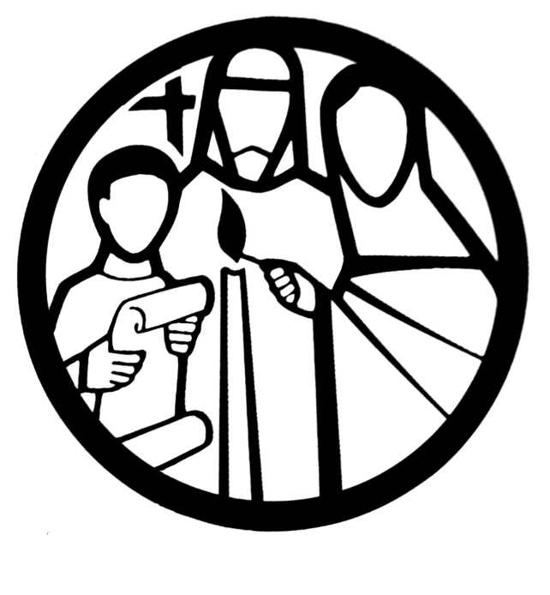
SO YOU WANT TO BE A DOCTOR

SOME TIPS AND ADVICE

Becoming a doctor
Thinking of becoming a doctor? Find out what qualifications you need and learn more about your potential career path.
Medicine is a caring profession and doctors provide a service to the public by diagnosing and treating illnesses, diseases and infections.
Doctors can specialise in a particular area, such as Ophthalmology or Paediatrics, according to their interests and skills.
Opportunities for doctors extend beyond the hospital environment, there are also opportunities available in other areas such as the armed forces, prisons, or the Home Office working as a police surgeon.

The challenge
Although medicine is frequently rewarding, it is a strenuous and challenging degree. Once you have become a doctor, it is vital that you continue learning new skills and training in order to not be left behind. As such life-long learning is integral to medicine – none of us wants to be treated by a doctor who is not up-to-date on new treatments and techniques.
It can take up to 12 years from studying medicine at undergraduate level to being appointed as a senior doctor (hospital consultant) or nine years to obtain GP status.
Doctors tend to work long hours and have to be on-call (available to work during the night) at certain times. On top of this, during your time as a house officer, you will also be studying for specialty exams which are understandably time consuming and demanding. When you graduate from medical school you begin your career as a pre-registration house officer. This allows you to learn more about medical practice whist working at your particular level of competency, knowledge, and skills.

Course entry requirements for a medical degree
The entry requirements for degree courses vary a great deal so check with the institution you’re interested in applying to.
Generally, medical schools seek a good grade in chemistry at A-level and increasingly they require A-level biology. Some universities may accept two science AS levels (including chemistry) in place of one A level science subject. One other science subject is often required, eg physics (or physical science), or mathematics.
A good A-level grade in an arts subject such as history or a modern language will usually be accepted as a third A- level. Applicants with A-levels in arts subjects will need good passes at GCSE level in the sciences.
All applicants will be expected to have good GCSE passes in English and mathematics.
Students with mainly non-science A-levels are normally required to study a foundation course, which is an extra year in addition to the standard five years.

The career path of a doctor
Medical degree (five years)
The undergraduate course provides students with some exposure to the different specialties within medicine. It involves practical clinical tasks and seeks to develop attitudes and behaviours appropriate to the medical profession, as well as the skills of independent learning.
Foundation year 1
Newly qualified graduates from medical school receive provisional registration from the General Medical Council (GMC) and undertake foundation year 1 (F1) which is designed to build on the knowledge and skills gained during undergraduate training. On successful completion of F1, trainees receive full registration with the GMC and can continue to the second year of foundation training.
Foundation year 2
Foundation year 2 (F2) training continues the general training in medicine and involves a range of different specialties, which could include general practice. By the end of foundation training, trainees must demonstrate that they are competent in areas such as managing acutely ill patients, team working and communication skills, to continue training in their chosen specialist area or in general practice.
Specialty and general practice training (three to eight years)
On successful completion of foundation training, doctors continue training in either a specialist area of medicine or in general practice. The area of medicine you choose will determine the length of training required before you can become a senior doctor. In general practice the training is of three years’ duration, and in general surgery, for example, the training is eight years in duration. During this period of training, doctors learn and practice increasingly advanced areas of knowledge and skills in their chosen specialty or general practice in order for them to be able to undertake senior doctor roles once training is completed. Postgraduate training is overseen by the Postgraduate Medical Education and Training Board (PMETB).
Continuing professional development
On successful completion of postgraduate training, doctors gain entry to either the GMC specialist register or general practitioner register and are able to apply for a senior post as a consultant or a GP principal, respectively. Whilst these posts are viewed as career pinnacles, all doctors are expected to continually demonstrate their fitness to practise medicine, and so learning continues throughout a doctor’s career
(Information taken from the British Medical Association website)

Related links
- Want To Be A Doctor
- NHS Careers
Student British Medical Journal

Careers in medicine
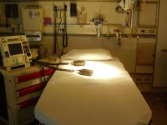
So, you think you might want to be a doctor? Deciding to study medicine will be the first of many choices.
There are more than 60 branches of medicine - each is unique but there are many common characteristics.
Medical specialisms broadly fall into one of the following categories:

Anaesthetics
Anaesthesia is not just about putting patients to sleep! Anaesthetists are essential members of the surgical team, and are also involved in developing treatments to relieve chronic pain and offering intensive care support to very sick patients.
- The Royal College of Anaesthetists
- The British Pain Society

General practice
GPs (General Practitioners) are the first point of contact with the NHS for most people. They provide a complete spectrum of care within the local community: dealing with problems that often combine physical, psychological and social components.
- Career profile: GP (General Practitioner)
- The Royal College of General Practitioners
- NHS

Medicine
Medical specialtisms cover a wide range of roles ranging from accident and emergency to clinical genetics. They cover most of the conditions for which people are admitted to hospital. Many of the specialties focus on particular organs such as the heart (cardiology), or disease processes such as cancers (oncology).
- The Royal College of Physicians
- NHS

Obstetrics and Gynaecology
Obstetricians and gynaecologists give specialised medical treatment and advice related to the female reproductive system, and care for women during pregnancy and childbirth.
- Royal College of Obstetricians & Gynaecologists
- NHS

Ophthalmology
Ophthalmologists diagnose and treat disorders related to the eye, orbit, and visual system.
- Career profile: Orthoptist
- Royal College of Ophthalmologists
- NHS

Paediatrics
Paediatricians diagnose and provide treatment for babies, infants, children and adolescents who have medical problems or are not developing properly.
- Royal College of Paediatrics & Child Health
- NHS

Pathology
Pathologists specialise in the detection of disease through the use of a variety of investigative techniques. They also play an important role in identifying sources of disease and reducing the possible risks of further spread.
- Career profile: Pathologist
- The Royal College of Pathologists
- NHS

Psychiatry
Psychiatrists deal with mental health. They will often combine a broad general caseload alongside an area of special expertise and research.
- Career profile: Psychiatrist
- Careers in psychiatry
- NHS

Radiology
Clinical radiology is the use of imaging to diagnose, treat and monitor various disease processes.
- Becoming a radiographer
- The Royal College of Radiologists
- NHS

Surgery
Surgeons specialise in operating on particular parts of the body, or address specific injuries, diseases or degenerative conditions.
- Careers in surgery
- Royal College of Surgeons
- NHS
Find out more about all the different specialisms as Medical Careers

What is a pre-medical year?
Do you want to study medicine?
Were your A-levels good but not in science subjects? Or are you worried that you are the first in your family to go to university?
If so, a pre-medical year might be just the thing for you.
It is available to medical school applicants who might not have studied the right subjects for immediate entry onto a medical course, such as chemistry or biology.
The courses also allow access to medical careers for students from particular areas of the country or less advantaged social backgrounds.
The course normally lasts about 30 weeks and covers chemistry, biology and physics. On completing the course you are then able to enter the standard five-year medical course.
The pre-medical year is also known as a foundation year (not to be confused with foundation training which doctors do after their medical degree).
Check the Med Schools Online website for information on which universities offer a foundation year.

Related links
- Is it worth applying to medical school?
- Life as a pre-medical student: Getting started
Want To Be A Doctor?

UKCAT explained
The UK Clinical Aptitude Test (UKCAT) is used in the selection process by some UK university medical and dental schools.

What’s the UKCAT for?
The UKCAT ensures that the candidates who apply to universities have the most appropriate mental abilities, attitudes and professional behaviours required for new doctors and dentists to be successful in their clinical careers. It doesn't test specific medical or scientific knowledge - it's about testing your thinking skills and judgement.

Sections of the UKCAT
The UKCAT is designed to test aptitude rather than academic achievement.
The test assesses a wide range of mental abilities. There are five sub-tests:
- Verbal reasoning, testing your ability to read written information and think carefully about it
- Quantitative reasoning, testing your ability to solve problems using numbers
- Abstract reasoning, testing your ability to make judgements about abstract information
- Decision analysis, testing how well you make decisions in uncertain situations
- Situational judgement, testing how well you can understand what's important in a situation and how you should behave

Preparing for the UKCAT
The UKCAT does not contain any curriculum or science content and cannot be revised for, although you can practice. It focuses on exploring the cognitive powers of candidates and other attributes considered to be valuable for health care professionals.
UKCAT has put together a candidate toolkit, including an official guide, practice tests and lots more.

Which university courses require the UKCAT?
View the latest list of university courses which require the UKCAT

When and where can I take the test?
There is no single date for sitting the UKCAT exam. However, UKCAT results are only valid for applications to universities in the year in which the test is taken. So, if you apply in 2014 to start medical school in 2015 but are not successful, you will have to resit the UKCAT if you re-apply next year.
Find out more about registering and deadlines
Because the UKCAT test is online, you can take it in almost any country around the world, provided there is a test centre.
Find a test centre near you

What does the test involve?
You'll take the UKCAT on a computer, with a fixed time limit for each question. You'll need to arrive at the test centre at least 15 minutes before your test to check in, bringing your email confirmation and photo ID.
During the test, you can flag a question to come back to later if you're not sure of the answer. You should try to answer all the questions, as you won't lose marks for incorrect answers.
You'll get the result of your test on the day, so you don't have to wait to find out whether you've passed.

Related links
- What is BMAT?
- BMAT top tips
- Exams
The UKCAT official guide

What is BMAT?
Passing the BMAT exam could be your golden ticket to studying medicine or veterinary medicine at the most exclusive universities. Read on to find out what's involved.
The BioMedical Admissions Test, or BMAT for short, is a two-hour admissions test vet or med students must sit to stand a chance of securing a place at the most exclusive universities.
It’s a way for those institutions to ensure they select only the very best calibre students.
Even if you don’t plan to apply to the institutions where the BMAT is compulsory, having it will give you the edge over other students applying for the other highly competitive veterinary medicine and medicine courses around the country.

Who needs to sit the BMAT?
Anyone planning to study certain medicine, veterinary medicine or related courses at the following universities:
- University of Cambridge
- Medicine
- Veterinary Medicine
- University of Oxford
- Medicine
- Biomedical Sciences
- Imperial College London
- Medicine
- Biomedical Sciences
- Biomedical Sciences with Management
- University College London
- Medicine
- The Royal Veterinary College
- Veterinary Medicine
- Combined degree programme
- Graduate accelerated Veterinary Medicine programme

How much is it?
The standard BMAT entry fee was £42.50 within the UK and £72.50 elsewhere in 2011. Check the BMAT website for changes in cost.

Where can I sit the BMAT?
You can take the BMAT exam at your school, college or sixth form.

What’s involved?
There are three parts:
- Section 1: Aptitude and skills. This is a 60-minute section consisting of 35 multiple choice or short answer questions.
It tests generic skills such as problem-solving, understanding argument and data analysis and inference abilities.
- Section 2: Scientific knowledge and applications. This is a 30-minute section consisting of 27 multiple choice short answer questions.
This section covers the sorts of things you will have studied at school in science and higher mathematics.
- Section 3: Writing task. This is a 30-minute section where candidates answer one of three short essay questions.

When does it take place?
The exam only takes place once a year so it's worth preparing well.
Check the BMAT website for future BMAT dates.

Related links
- How to apply to medical school
- What is UKCAT?
- BMAT top tips
- Exams
Example BMAT test papers

How to get medical work experience
Andy Carson-Stevens, a second year medic at Cardiff University, explains how you can create your own work experience opportunities.
I’m always surprised when prospective students tell me that they can’t get work experience. There are so many opportunities out there - you just have to know where to look.
With the increasing demand for medical school places, you really need the WOW factor on your application if you’re going to be in with a chance, and work experience is where you can stand out from the crowd.
When I was looking for work experience, I didn’t have any contacts in the medical world, so it was really a case of starting from scratch. I wrote off to a hospital consultant I chose at random from the NHS Trust website. In the end, loads of exciting work experience opportunities came out of this ONE initial letter.
At the time, we were studying the heart in biology so I shadowed a cardiothoracic consultant for a week. A keen approach taken during this week led me being passed on to Accident and Emergency for a week with his colleague. This work experience then provided the ideal springboard to compete for a national competition for a placement in London, which I was luckily chosen for. Eventually I had so much experience it would just about have fitted on three A4 sides let alone that small space on the UCAS form.
You don’t have to get work in a hospital: if you try all the local doctors and NHS trusts with no luck, try being inventive. Look for jobs in a local pharmacy (ideally dispensing), a local nursing home (once a week) or try visiting research centres for the day. Initiative is definitely the key for getting your foot in the door in medicine.

Related links
- Why is medical work experience so important?
- Work experience in the NHS
- UK Nursing Homes Directory
Medical Research Centres

